

In Situ Water Quality Measurement System

Abdullah Alghamdi, Carter hoyle, Michael Bertram, Grayson mobley

Final Report | EMCH 428 – Design 2



April 24, 2023

Department of Mechanical Engineering | University of South Carolina: Columbia, SC

Industry Sponsor: Dr. Austin Downey | The ARTS Laboratory

1. **Table of Contents**

Cover Page: 1

Table of Contents: 2

Executive Summary: 3-4

Background: 7

Customer Needs: 8-15

Project Specifications: 16-21

Functional Concepts: 22-31

Concept Selection: 33-35

Product Architecture: 36-39

Engineering Analysis: 40-50

Manufacturability: 51-56

Product Cost/ Economic Analysis: 58-62

Testing: 63-67

Final Design: 68

Conclusions: 69-71

Appendix: 72-73

1. **Executive Summary**

Dr. Austin Downey is a Professor at the University of South Carolina, and he oversees the Adaptive Real-Time Systems (ARTS) Laboratory that specializes in developing tools for systems that can adapt to the environment in real time. They want a product that does that can measure conductivity, pH, and temperature of water, provide adequate flow for fresh sampling, keep electrical components safe from water damage/heating damage, and will be able to transmit data to a server so they can have a device that can be compatible with the NMR.

The needs of Dr. Downey were determined by the project scope which gives a description of what the project entails and its deliverables, and the various project meetings that were held with the project sponsor, and after detailed analysis, it was determined that having sensors that can measure pH, measure conductivity, measure temperature, ease of manufacturability, keeping electrical components dry, and withstand various weather conditions were critical to satisfying those needs. It was furthermore determined that a product to satisfy their requirements would need to measure fresh water’s conductivity, temperature, and pH value. The key product specifications are running without maintenance for 2- 6 days, average power consumption around 6.5 Watts, and flow rate to be around 11.36 liters per minute. It was thus determined that the product mission should be: The ARTS-Lab at the University of South Carolina needs a device that can measure conductivity, pH, and temperature of water, provide adequate flow for fresh sampling, keep electrical components safe from water damage/heating damage, and will be able to transmit data to a server.

Given the above requirements, multiple concepts were researched and considered, as described in this report. The ultimate concept selected to best satisfy Dr. Downey’s needs was a design that includes the out of water, series flow​. The concept was considered the best when scored against other ideas for its simplicity and ability to transmit data with low energy consumption. The product architecture concerning this concept outlined the interactions between the sampling water, power source, microcontrollers and the data transmitted to the cloud.

Circuitry, temperature regulation, pressure, and power regulation are critical to functionality, and detailed engineering analyses are provided, demonstrating how pressure change, current usage, and temperature variation were modeled, under peak outdoor operating conditions. The design was optimized for clearer sensor readings, lower temperature gradients, and as-designed power constraints as a result.

Because parameters of component selection (Power supply), protection (Power Supply), stability (Hydronics sensors), and symmetry (PVC piping) are high priorities for production of the product, the design was optimized for these parameters as well, which consisted of comparing 50-Watt and 60-Watt power supplies, designing a 3D printed cover for the power supply, using three PVC tees and cable glands to secure the hydronics sensors, and cutting the PVC pipe into 4 equal sections.

The prototype was tested by doing flow rate and circuit analysis, as well as an endurance test condition ranging from indoor, protected conditions to exposed, outdoor operating conditions.

Economic analysis of the scope of expenses associated with development of the prototype indicates that, for a $652.91 investment (including labor), Dr. Downey will recover costs within 3 months.

This design was determined not to be a viable start for water quality measurement. The design performed within the specifications that were listed, but in testing, the effectiveness of the water quality measurement was lackluster. The design has room for many new specifications for the design to become viable in the future. It is suggested that the prototype undergoes a major redesign with the knowledge learned from the tested components and their orientation.

1. **Background**

The University of South Carolina Adaptive Real-Time Systems (ARTS) Lab specializes in developing tools for systems that can adapt to the environment in real time. They have done work on machine learning, sensor packaging, autonomous and embedded systems, real time control, and artificial intelligence. Their goal is to build interdisciplinary systems that can be applied to various mechanical, aerospace, computer, and civil infrastructures.

The purpose of this project is to develop a system that hosts a suite of sensors for collecting, processing, and transmitting data remotely to a central server. The system will initially measure conductivity, pH, and temperature and integrate a custom NMR sensor developed by the ARTS-s Lab. The system would be expandable while providing power management and cooling. In-depth thermal models of the system will need to be developed for analysis. The goal of the project is the development of a flow-through water quality measurement system.

1. **Customer Needs**

**5.1 Introduction**

The project is an In-Situ Water Quality Measurement System, and the sponsor is The Adaptive Real-Time Systems Laboratory (ARTS-Lab) at the University of South Carolina. The project contact is Austin Downey, Assistant Professor. The design is a concept that can transmit collected data from sensors to a remote server using CAD files and source code. Using an Atlas Wi-Fi sensor which has a temperature, conductivity, and pH probes, the design will collect readings for pH value, conductivity, and temperature readings of flowing water, because the goal of the project is to development of a flow-through water quality measurement system. The readings will be collected from the creek water located behind the 300 Main St. building. This design incorporates pumps, plastic tubing, and PVC pipes to control the water going into the system. The stake holders are Dr. Downey and graduate students working in the ARTS Lab because they will be using the product and readings to benefit the NMR sensor.

**5.2 Methodology**

To find the needs necessary for the project, we used two sources. Those being the project scope which gives a description of what the project entails and its deliverables, and the multiple project meetings that were held with the project sponsor. From the scope we were able to create needs that met the requirements for what was stated, such as being able to measure pH, conductivity, and temperature of the water. The project sponsor meetings also gave insight as to certain conditions that are necessary for the project such as being able to run for a week without maintenance and being compatible with the NMR box. There is a graduate student in the ARTS Lab working on a similar project, but his system is much different. He gave some recommendations but overall wasn’t helpful with developing needs for this system.

From the information above, a list of needs is produced:

* Run for a week w/o maintenance.
* Last for months on end.
* Fit into the ditch behind 300 Main Bldg.
* Remain secured to the base of the trench to prevent drifting.
* Cost effective.
* Have a cooling system (ex. water cooling).
* Safely run when unsupervised.
* Be able to measure conductivity, pH, and temperature of water.
* Be compatible with the NMR Box.
* Be easy to understand for use.
* Be able to have water at room temperature.
* Collect data from sensor.
* Be able to transmit data to a server.
* Be able to work in water.
* Keep electrical components safe from water damage/heating damage.
* Show thermal modules.
* Be able to adjust the power of sensors and pumps.
* Be able to work in certain temperatures.
* Be expandable, so more work can be done on it.
* Be able to be removed (for maintenance when necessary).
* Be easy to install.
* Differentiate between room temperature water and other forms of water (pH, temperature, conductivity)
* Check water in real time.
* Be able to differentiate bacteria in water.
* Measure flow rate.
* Have separate sensors to give feedback on the design, i.e., thermometers on important components.
* Have no negative effects on the water it is measuring.

**5.3 Interpretation of Needs**

The product needs to be able to run for a period without maintenance, as well as last for a few months. This is important because the product must run without the engineers constantly around it.

The product needs to be small enough to fit into the ditch behind 300 Main St. building but also big enough to where it won’t float downstream.

The product needs to fit the budget given by the sponsor, which means each part must be carefully selected and the price of each part must be taken into consideration.

The product needs to have a cooling system since the product will be outside in the heat or in the sunshine. Also, the product will be in an enclosed box so the internal temperatures will rise.

When the product is unsupervised, it must run safely without products overheating and blowing up. Overheating components will cause an unsafe environment, which is unacceptable because it could hurt someone passing by or cause environmental damage.

The product must measure the pH, temperature, and conductivity of the flowing water. This means the product must incorporate three sensors to measure these values.

The product needs to be compatible with the NMR box provided by the sponsor. This means the product must either have the NMR box incorporated into the design or the readings collected from the product must be able to transmit to the NMR box.

The product must be easy to use. This means any engineer from the ARTS lab can use our product to collect data without confusion or problems with using the product.

The product needs to have a component consisting of water at room temperature to use as a base for the temperature, pH, and conductivity data collected.

The product must collect data from the sensors and then transmit that data to a server. This means that the sensors that are selected must work properly, and the design needs to have a device that can send the data collected to either a computer or phone.

The product must be able to work in water. The product isn’t going to be submerged in water, but it will be partially in water, so it needs to be either sealed or water resistant, so water doesn’t get inside of the product and get the electrical components wet.

The product needs to show thermal modules, meaning the user can see which parts or components are heating up so appropriate changes can be made to ensure the correct temperature of said components.

The product needs to be able to adjust the power of the sensors and pumps, because the sensor and pump require different power inputs. This can be achieved by using a voltage regulator.

The product must work in various outside conditions such as in the heat, the cold, and in humid environments. This is important because the product must run for multiple weeks and in South Carolina the weather can drastically change in a matter of a few weeks.

The product needs to be expandable so future work can be done on it, be able to be removed, and be able to be easily installed. This means the design will incorporate a removable frame consisting of the different components inside of the product. This frame can’t be mounted to the box but also needs to be fitted to the box, so the frame isn’t moving inside of the box.

The product needs to check water in real time which means that the sensors need to transmit data as soon as the water passes the sensors, then transmit the data immediately.

The Product needs to determine if there are bacteria in water. This is done using conductivity probes. The more polluted the water is, the higher the conductivity level will be.

The product needs to measure the flow rate of the water in the system. This is important because if the flow rate is too small then the sensors won’t be getting new water to test, and if the flow rate is too high then the tubing can burst causing the inside to get wet.

The product needs to have separate sensors to provide feedback on the design. This can consist of thermoset sensors to tell which components are getting hot and overheating.

Lastly, the product needs to have no negative effects on the water it is collecting because after the water is sampled, it will go back out of the creek. This is achieved by using electricity from and outlet to power the product. There can’t be any gases or particles from the product contaminating the water.

**5.4 Prioritization of Needs**

There were originally 27 customer needs produced after discussing with the sponsor and using the project scope. This is way too many needs to create a product, so a voting process was created to eliminate unnecessary needs and to find the most important needs to include in the product mission statement. The voting process started by creating an excel sheet with the original 27 needs and then splitting them into 3 categories for round 1 of voting. Each team member ranked what is believed to be the most important needs out of each category on a scale from low to high. For the first category, each member was allotted a total of 21 points, and the 21 points were distributed based on the importance of needs in that section. For example, the most important need would be given a score of 1 and the least important would be around 10. For the second category of round 1, each team member was allotted 66 points to distribute, and in the third category each team member was allotted 55 points to distribute. After the team finished voting, the scores were added up for each need and given a rank based on how low the total score was. It's like golf, the lowest score wins.

*Table 5.1: Round 1 of Voting on Needs*.

|  |  |  |  |  |  |  |
| --- | --- | --- | --- | --- | --- | --- |
| **Round One** |  |  |  |  |  |  |
| Needs to: | Grayson | Carter | Abdullah | Michael | Total Score | Overall Rank |
| Run for a month w/o maintenance. | 2 | 2 | 6 | 4 | 14 | 3 |
| Last for months on end. | 5 | 6 | 5 | 5 | 21 | 6 |
| Fit into the ditch behind 300 Main Bldg. | 6 | 5 | 3 | 3 | 17 | 5 |
| Be cost effective. | 4 | 4 | 2 | 6 | 16 | 4 |
| Have a cooling system | 1 | 3 | 1 | 2 | 7 | 1 |
| Safely run when unsupervised. | 3 | 1 | 4 | 1 | 9 | 2 |
| - | - | - | - | - | - | - |
| Be able to measure conductivity, pH, and temperature of water. | 2 | 1 | 1 | 2 | 6 | 1 |
| Be compatible with the NMR Box. | 1 | 2 | 2 | 1 | 6 | 2 |
| Be easy to understand for use. | 9 | 8 | 7 | 4 | 28 | 7 |
| Be able to have water at room temperature. | 8 | 9 | 8 | 10 | 35 | 10 |
| Collect data from sensor. | 7 | 3 | 4 | 9 | 23 | 6 |
| Be able to transmit data to a server. | 4 | 5 | 5 | 5 | 19 | 4 |
| Be able to work in water (water resistant). | 3 | 10 | 3 | 7 | 23 | 5 |
| Show thermal modules. | 10 | 6 | 9 | 6 | 31 | 9 |
| Be able to adjust the power of sensor. | 5 | 7 | 10 | 8 | 30 | 8 |
| Be able to work in certain temperatures (heat, humidity, cold). | 6 | 4 | 6 | 3 | 19 | 3 |
| Be expandable, so more work can be done on it. | 11 | 11 | 11 | 11 | 44 | 11 |
| - | - | - | - | - | - | - |
| Be able to be removed. | 7 | 8 | 7 | 7 | 29 | 8 |
| Be easy to install. | 6 | 7 | 6 | 10 | 29 | 7 |
| Differentiate between room temperature water and other forms of water (pH, temperature, conductivity) | 8 | 5 | 8 | 5 | 26 | 6 |
| Check water in real time. | 3 | 6 | 5 | 1 | 15 | 4 |
| Be able to differentiate bacteria in water. | 10 | 9 | 9 | 9 | 37 | 10 |
| Remain secured to the base of the trench to prevent drifting. | 1 | 4 | 4 | 2 | 11 | 3 |
| Keep electrical components safe from water damage/heating damage. | 4 | 2 | 2 | 3 | 11 | 2 |
| Measure flow rate. | 2 | 1 | 1 | 6 | 10 | 1 |
| Separate sensors to give feedback on the design, i.e., thermometers on important components. | 5 | 3 | 3 | 8 | 19 | 5 |
| Have no negative effects on the water it is measuring. | 9 | 10 | 10 | 4 | 33 | 9 |

Round 2 consisted of the top 4 needs of each category from round 1 which resulted in 12 total needs. These top 4 needs are considered critical to quality (CTQ’s). Round 2 was not split into different sections, just one big section. The voting process changed a little bit for this round. Each team member voted on a scale of 1-12 with 1 being the most important and 12 being the least important, instead of each member given a total amount of points to distribute. After every team member voted, the six lowest ranked needs became the most important CTQ’s, the mission statement will consist of these top six CTQ’s. It was determined that focusing on a maximum of 6 CTQ’s will improve the design concept without having to worry about focusing on needs that the sponsor thinks will be irrelevant.

*Table 5.2: Round 2 of Voting on Needs.*

|  |  |  |  |  |  |  |
| --- | --- | --- | --- | --- | --- | --- |
| **Round Two** |  |  |  |  |  |  |
| Needs to: | Grayson | Carter | Abdullah | Michael | Total Score | Overall Rank |
| Have a cooling system (ex. water cooling). | 1 | 10 | 8 | 9 | 28 | 8 |
| Safely run when unsupervised. | 6 | 9 | 7 | 7 | 29 | 9 |
| Run for a month w/o maintenance. | 4 | 7 | 9 | 8 | 28 | 7 |
| Be cost effective. | 11 | 12 | 10 | 12 | 45 | 12 |
| Be able to measure conductivity, pH, and temperature of water. | 2 | 1 | 1 | 1 | 5 | 1 |
| Be compatible with the NMR Box. | 7 | 5 | 6 | 4 | 22 | 5 |
| Be able to work in certain temperatures (heat, humidity, cold). | 8 | 8 | 11 | 10 | 37 | 10 |
| Be able to transmit data to a server. | 12 | 2 | 4 | 2 | 20 | 4 |
| Measure flow rate | 3 | 3 | 2 | 3 | 11 | 2 |
| Keep electrical components safe from water damage/heating damage | 5 | 4 | 3 | 6 | 18 | 3 |
| Remain secured to the base of the trench to prevent drifting | 9 | 11 | 12 | 11 | 43 | 11 |
| Check water in real time. | 10 | 6 | 5 | 5 | 26 | 6 |

  The top 6 design needs that are critical to quality are:

1. Be able to measure conductivity, pH, and temperature of water. (Clear 1st)
2. Measure flow rate. (Clear 2nd)
3. Keep electrical components safe from water damage/heating damage.
4. Be able to transmit data to a server.
5. Be compatible with the NMR Box.
6. Check water in real time.

**5.5 Product Mission Statement**

Using the top final needs that are critical to quality determined from the voting processes, a mission statement was created: The ARTS-Lab at the University of South Carolina needs a device that can measure conductivity, pH, and temperature of water, will measure flow rate, will keep electrical components safe from water damage/heating damage, and will be able to transmit data to a server.

1. **Project Specifications**

**6.1 Introduction**

The purpose of this report is to identify metrics for the customer requirements and to create target specifications using a House of Quality approach. After the metric table was created, a House of Equality table was created. This table compares the customer requirements with the engineering characteristics, to create a ranking of the engineering characteristics. Lastly, a target/fallback table was created. References were used to determine the target specifications and the fallback specifications for each. Key outcomes of this chapter are defining the target and fallback values of necessary metrics, determining the critical engineering characteristics to focus on, and which metrics will be challenging to satisfy.

**6.2 Methodology**

*Table 6.1: Customer Requirements and Metrics for In-Situ Water Testing Suite*

|  |  |  |
| --- | --- | --- |
| **Sponsor Requirements** | **Metrics** | **Units** |
| Compare conductivity to NMR | Measures conductivity | [EC] |
| Compare pH to NMR | Measures pH | None |
| Track natural water temperature | Measures temperature | [C] |
| Measures flow rate | Measures flow rate | [Liter/Min] |
| Electrical components must stay dry | Electrical components must stay dry | [Boolean] |
| Electrical components will remain functional in all weather conditions | Temperature regulation near operating temperature of electrical component | [C] |
| The suite will supply water flow compatible with the NMR Box. | Fluid temperature change over time | [C/Min] |
| The suite will transmit data wirelessly in real time | Data sets per unit time | [Data Sets/Min] |
| The suite will require minimal maintenance | Time without maintenance | [Days] |
| The suit must be able to be carried with ease. | Portability | [Lb] |
| The suite must have enough power supplied for the pumps and sensors to work | Average Power consumption | [Watts] |

The sponsor requirements list in table 6.1 were produced from the voting system in chapter 5. Also, a few more were added in this section based on suggestions from the faculty mentor, such as portability and average power consumption. This design is primarily about supporting the Nuclear Magnetic Resonance (NMR) box. Primary needs in the design are regulating fluid properties for use in NMR. In the process of regulating the fluid, there are many opportunities to collect more data on the flowing water. The fluid properties that are to be measured reflect the customer’s criteria for satisfaction.

Data collection includes conductivity, temperature, flow rate, and pH. Temperature and flow rate are both properties that are important for the NMR and general regulation of the design. pH and conductivity give typical, valuable information regarding the water in the reservoir.

To make the data collection accessible and useful for the customer, the data was recorded electronically. Rather than physically checking the data at the site of the product, there should be capability to send data wirelessly for viewing. Wireless data viewing, as well as automatic compilation of data, requires electrical components, which must be kept dry and properly sustained for the duration of its use, hence the requirement for steady temperature of components.

**6.3 Needs Metrics Matrix (or House of Quality)**

The House of Quality begins with taking the customer requirements stated in the Specifications Metrices. Engineering characteristics were then formed based on what is necessary for all the requirements to produce a satisfactory product. This led to the characteristics of Power input, Temperature Regulation, Fluid Pressure, Ease of Access, Height, Length, Width, Product Stability, and Cost to Manufacture. Appropriate units were given based on said characteristics, and then an improvement direction was given based on whether increase or decrease a certain characteristic would improve to the product. Each Customer Requirement was then given an Importance Weight Factor for the entire project. Numerical values were used from 1-5 with 1 being least important and 5 being the most. Each requirement would then correlate to specific engineering factors that they would affect, and then receive a numerical value from 1 to 9, with 1 representing slight contribution, 3 being moderate, and 9 being the strongest contribution. The weight factor would then be multiplied in each row to the contribution number and added altogether in the column. These columns would be added all together to form a raw score, with a weight percentage given using each column’s sum divided by the raw score multiplied by 100. Unlike how the needs were ranked in the voting process in chapter 5, the ranking in the House of Quality matrix were based on how high the score is. The more points means that it is more impactful to product quality and customer satisfaction.

*Table 6.2: House of Quality Matrix*

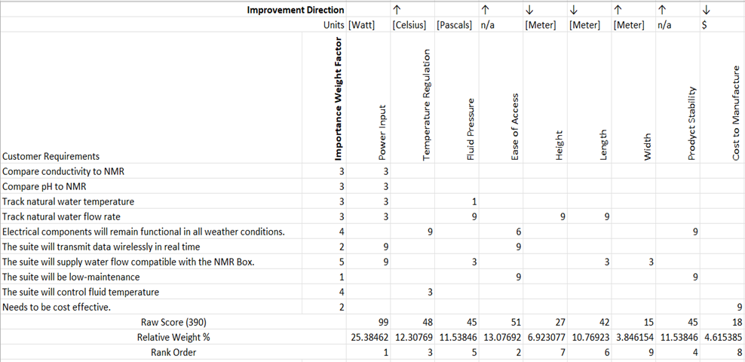

In observation, the requirement Track natural water flow rate and the suite will supply water flow compatible with the NMR box have the highest number of matrices, those being power input, fluid pressure, height, length, and width. Power Input will have a strong focus because of all the different processes it needs to power, including all the different quantities measured in the water (temperature, pH, conductivity).

**6.4 Target and Fallback Specifications**

After team members discussed each need target, which are the ideal goal that could be achieved. The second phase of searching and looking to the probability of the ranges to achieve this target.

The target values were obtained after meeting with the project sponsor, Dr. Downy, and talking about the needs report to identify the method of how the system will collect the data needed. To know the targets of this system, searching on the internet for systems and sensors that are already on the market to know the range of how these systems work.

The table below (Table 6.3) illustrates the targets for the metrics and the fallback values. Also, the reference number. As mentioned before. Similar systems properties like Arduino were valuable resources to identify the targets of this project.

*Table 6.3: Target and fallback values for the metrics*

|  |  |  |  |
| --- | --- | --- | --- |
| **Metrics** | **Units** | **Target Specification** | **Fall Back** |
| Measures conductivity | [EC] | 750 | 500 - 1000 |
| Measures pH | None | 7 | 6.5 - 7.5 |
| Measures temperature | [C] | 22 | 21-23 |
| Measures flow rate | [Liter/Min] | 11.36 | 7.75 - 15.14 |
| Electrical components must stay dry | [Boolean] | True Positive | TP - TN |
| Temperature regulation near operating temperature of electrical component | [C] | 23 | 40 - 60 |
| Fluid temperature change over time | [C/Min] | 5 | 20 |
| Data sets per unit time | [Data Sets/Min] | 0.2 | 0.1 |
| Time without maintenance | [Days] | 10 | 2 - 6 |
| Portability | [Lb] | 40 | 25 - 55 |
| Average Power consumption | [Watts] | 6.5 | 5.0 - 80 |

**6.5 Conclusions**

Based on table 6.2, the critical engineering characteristics of the design are the power input, ease of access, temperature regulation, product stability, and fluid pressure. The height, width, and length of the product aren't too impactful on the design and the sponsor supplied a container for the product that had a set height, width, and length. Also, the cost of the design meets the budget because most of the materials were supplied from the ARTS Lab.

The metrics that will be challenging to satisfy are temperature regulation near operating temperature of electrical components, and time without maintenance. The temperature of the electrical components will get hot while the product is running continuously and since the product will be outside and in an enclosed container. Also, the time without maintenance will be challenging because the electrical components may overheat after a day of running which will require maintenance, and there isn't a design to keep the product from getting stolen when left without supervision.

1. **Functional Concepts**

**7.1 Introduction**

This report is meant to break down the design concepts of the product and to identify its functions. It will also cover several different ways that the needs of the product are satisfied, which will be evaluated in the next week to determine the viable options for the design. After the functional decomposition, a few design concepts will be reviewed as potential directions for our design to take.

**7.2 Functional Decomposition**

Functional decomposition is a process used to ideate design details. It begins by determining the functions that a product must entail to be considered satisfactory to a customer. These functions will be mapped in a diagram that tracks interactions between functions, like materials, energy, or data.

The functional diagram and functions are listed as follows:

* Measure pH of water sample
* Measure conductivity of water sample
* Measure temperature of water sample
* Measure flow rate
* Transmit data to a server
* Receive power
* Temperature adjustment
* Extracts water samples
* Receives user's input
* Stores/ejects sample

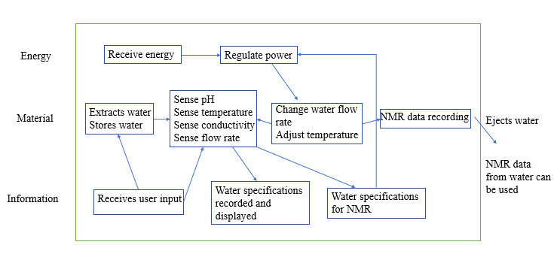*Figure 7.1- Functional Diagram*

There are three flowing components that are important in the functional diagram to track: energy, material, and information. The energy in the product is related to the sensing functions as well as any functions that are required to do work of any kind. In the diagram, notice that energy is received, then regulated. No matter what, the energy in the system is regulated before it is utilized in other components. Power is going to be related to the water flow and to the heating and cooling of the water for the NMR box. The pH, temperature, conductivity, and flow rate sensing are all going to be derived from materials, or plainly the water flowing through the design. The NMR box will also be taking data from the material (water), and it will finally leave the sensing suite back to the reservoir or flowing stream. Information that the design obtains is specifications regarding the water flow. Notice that specifications regarding the NMR are fed back into the power regulation to change variables in the flow and temperature of the water.

Conclusively stated: the product needs to receive user’s input, intake and store flowing water, record data on the water, regulate the flow and temperature of the water, adjust the temperature, fill the NMR box adequately before it is returned to the reservoir, and eject the water back into the creek.

**7.3 Concept Combination**

A concept combination table (CCT) is a step in the concept generation process. Multiple functions that the intended system must follow will be in the top row of the table. Each function will then have its own column of different ways to achieve that function. CCT is useful because it helps generate a clear combination of elements for the design out of a long list of different options. The system must have a source of energy, a way to turn on the equipment, and receive the user’s input. It must also extract water from the creek and receive and send Values of ph., flow rate, conductivity, and temperature from the water samples. It must eject the sampled water back into the creek

*Table 7.1: Concept Combination Table*

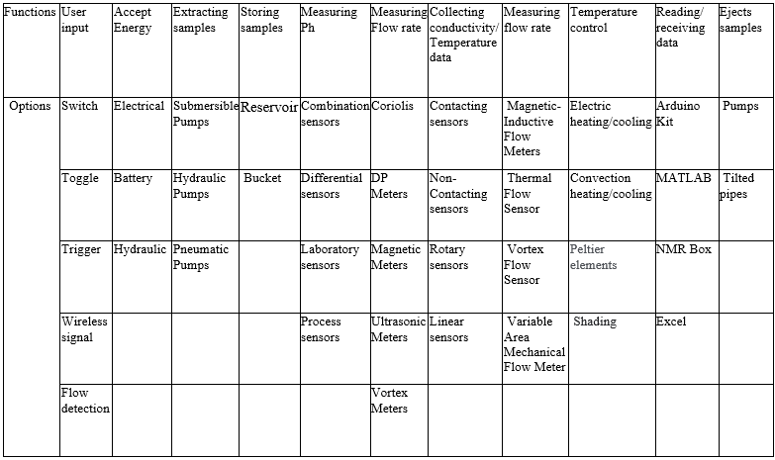

**7.4 Concept Generation**

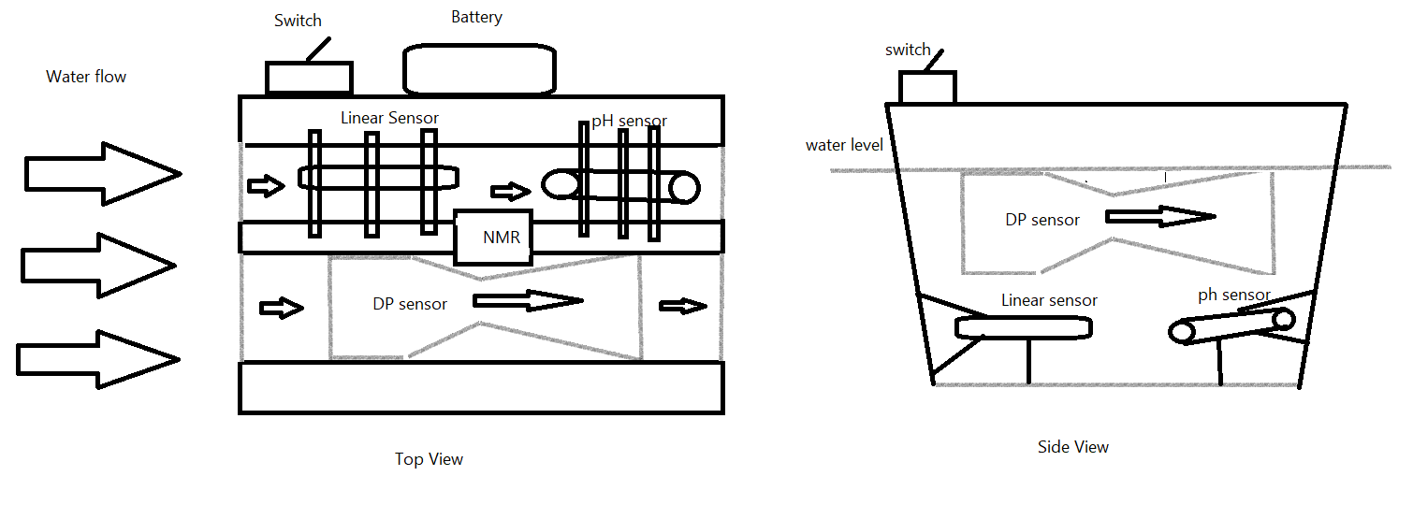

*Figure 7.2 – Concept design*

The design in figure 7.2 had the following concept combination: an on/off switch, a battery, a combination ph. sensor, differential pressure (DP) meter, linear sensor, shading from environment, and an NMR box. The system is split into two streams to make room for all three sensors. The sensors are powered from a battery attached to the outside and above the water flow to protect it from getting wet. The linear and ph. sensors will be submerged in the water but attached to the apparatus with multiple metal rods to ensure the sensors don’t break off. The use of a venturi tube design can measure flow rate. All the sensors will transfer the data collected to the NMR box which will then be transmitted to a server/ user interface.

*Figure 7.3 – Concept Design*

Figure 7.3 features another design that uses a hydraulic pump and a water inlet line to bring pressurized water into the suite. A pressure gauge, sensing suite, temperature regulator, and the NMR box all receive and distribute water in that order at the same height from the water’s surface. A key difference in this design than to the one in figure two is that it is completely out of the water, and one of the needs that may be challenged is temperature control of both the electronics and of the water. Without being in flowing water, natural cooling won’t be able to contribute to the exterior of our design.

*Figure 7.4 – Concept Design*

Figure 7.4 is the third concept idealized. Key features to this design concept are a valve, internal water reservoir, and heating apparatus attached. The design of the reservoir makes heating incredibly simple to design, but likely difficult to keep consistent temperatures for NMR box intake. Power to the internal reservoir and therefore the heat added to the fluid would be dependent on one of two thermometers measuring the temperature of the water. The water also may not contain particles that are expected for the NMR box, because if they have different masses and aren’t in a constant state of flow, it’s possible for a residue buildup in the reservoir that could improperly affect results.

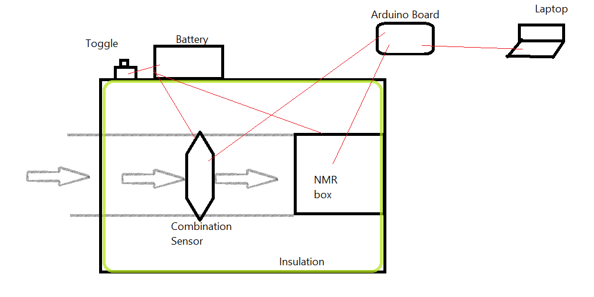

*Figure 7.5 – Concept Design*

The design in figure 7.5 consists of a toggle switch, a battery, a combination sensor, insulation, NMR box, Arduino board, and a laptop. The system will be powered by a battery with a toggle attached. The battery will power a combination of ph., temperature, and conductivity sensors all in one, as well as powering the NMR box. The sensors and NMR box are connected to an Arduino board configured to receive the data collected and then transmit the data to a nearby laptop or computer to display the data. The system will be in a plastic or metal box, and the box will be insulated for temperature control.

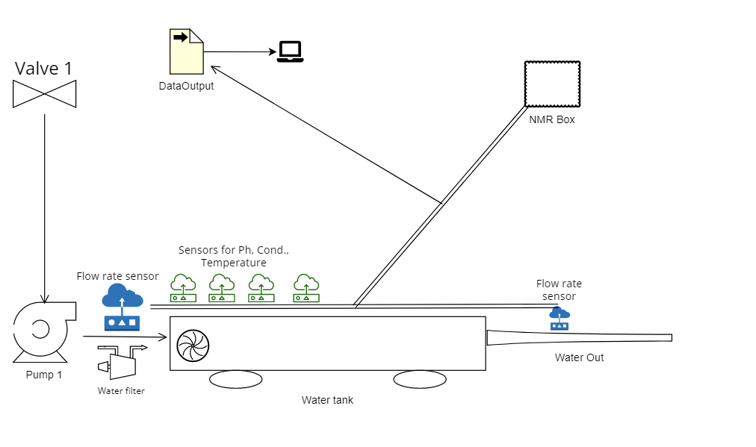  
*Figure 7.6 – Concept Design*

The concept design in figure 7.6 contains a valve, a submersible pump and water tank prepared with suite of wireless sensors to measure the required properties. Such as Ph, conductivity, water temperature and flew rate in and out of the system. The water tank is equipped with a temperature controlling system as well as a water filter for keeping the samples flow clean. The system is connected to NMR Box and wirelessly sends data to be stored and viewed on a computer.

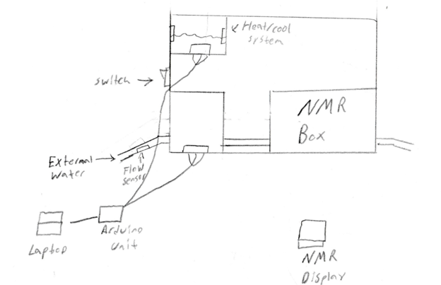

*Figure 7.7 - Concept Design*

The concept design in figure 7.7 is battery powered and uses a switch to execute overall functions. A water inlet for an external water source along with a pneumatic pump is used to bring water inside of a compartment. This inlet will have a flow rate sensor within and will be connected to the Arduino unit. Once in the compartment, a set of sensors will be used for the pH, conductivity, and the temperature of the external water. These sensors will also be connected to the Arduino unit. Above this Compartment is a second reservoir which will hold a certain amount of water. This reservoir will have electrical heating and cooling in order to regulate the water within to a certain temperature (this will most likely be room temperature). This reservoir of water will be used as a basis of comparison for the external water coming in, with its own set of Arduino sensors. A laptop will be connected to the Arduino unit showing all values of both compartments, as well as a separate display for the flow rate. The external water will then be transferred to the NMR box. Once its data has been collected, the NMR data will have its own display for information. The external water is then let out through an outlet in either a compartment attached, or a larger body of water.

**7.5 Research Performed**

The research performed was conducted on Google’s patent searching website, scholar.google.com. Some of the patents researched included key words like heating, cooling, flow, control, feedback, and water. We also researched current patents on nuclear magnetic resonance (NMR), as it is going to be related to details of the design. A venturi tube used for flow rate measurement was found using the key words differential pressure meter.

**7.6 Conclusions**

Some of the important factors in our concepts revolve around temperature control and the order of operations regarding the sensing and temperature regulation of the materials. Regarding order of operations, consideration must be paid to the customer’s requirements. When should the conductivity be sensed? When can the temperature be sensed, and where? Should there be more than one thermometer in the system? All of these questions will be taken into account in the future selection of concepts. The customer most primarily needs to collect data on the water and then make it compatible with the NMR box.

1. **Concept Selection**

**8.1** **Introduction**

The aim of concept generation and selection is to develop several plausible solutions for the customer and evaluate them according to critical selection criteria to meet their needs. A selection matrix is used to screen these concepts and score them based on the selection criteria. The selection process involves a subjective ranking to determine the reference concept, and other concepts are rated as better, as good as, or worse than the reference concept. The grades are aggregated into net scores, which provide a more objective ranking of the concepts. This approach prioritizes customer needs and helps select the best option without bias.

**8.2 Concept Screening**

Six selection criteria are used to evaluate each concept: durability, power efficiency, component safety, cost-effectiveness, ease of cooling, and data availability. To create a rating table, a reference concept is chosen for comparison, and each subsequent concept is evaluated against the reference based on each criterion. The concept receives a “+” if it outperforms the reference, a “0” if it is equivalent, and a “-” if it is inferior. The total number of “+”, “0”, and “-” are tallied to calculate the net score, which is the difference between the total number of “+” and “-”. The ranking of the concepts is based on the net score, with the top-ranking design having the highest net score.

**8.3** **Concept Ranking**

*Table 8.1 – Concept Selection Matrix, round 1*

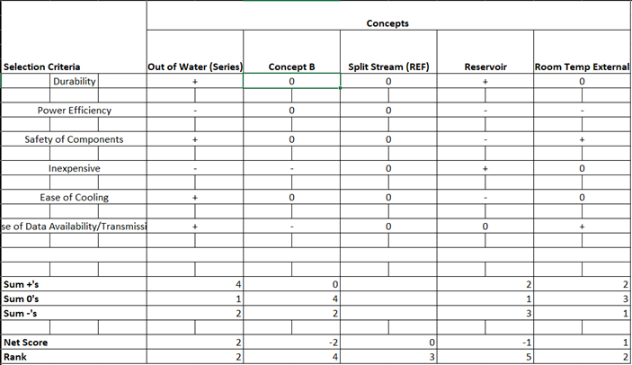

*Table 8.2 – Concept Selection Matrix, round 2*



In the second round of concept selection, Concept B and the reservoir design were eliminated. Concept B's performance was unsatisfactory in terms of cost-effectiveness and data availability, while the reservoir concept had poor ratings in power efficiency, ease of cooling, and component safety. The remaining two concepts were compared against the reference concept using the same selection criteria. The Out of Water concept received a higher overall score, making it the top-ranked design.

**8.4 Final Concept**

The final concept chosen was the Out of Water, Series Flow design. This design utilizes an Atlas Scientific Hydroponics kit with probes attached to a 5mm (about 0.2 in) tube, regulated by a battery-powered pump. The design's key features include its simplicity, compatibility with NMR, and wireless data collection capabilities. However, there are challenges that need to be addressed, such as powering the pump, ensuring sustainability, and meeting the NMR box's water source criteria for sample testing. For the NMR box to function correctly, a static water source must be provided.

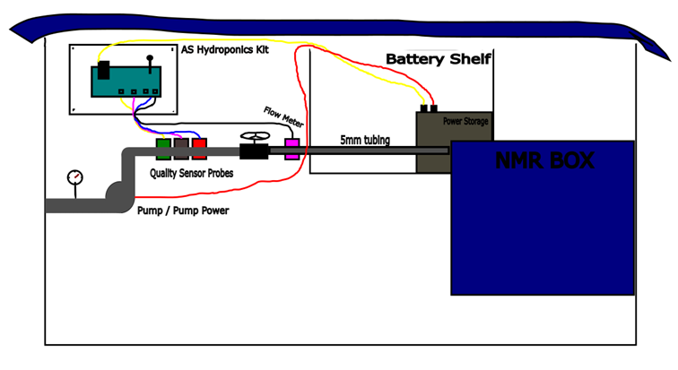

*Figure 8.1 – Out of Water, Series Flow Concept*

The selection of this concept has introduced new design criteria. The customer has requested a power profile of the design's components to make it self-sustaining. The pump and flow meter will need to work together to refill the NMR with fresh water after each data recording interval. This design was deemed the most suitable starting point for meeting the project's scope and delivering a product that meets the customer's needs.

1. **Product Architecture**

**9.1** **Introduction**

Product architecture refers to the organization of a product's functional elements into physical building blocks, often achieved through clustering, as shown in Figure 1. Key considerations for making architecture decisions include the placement of elements relative to each other, which elements should be grouped together, and whether they should be integrated or modular. Figure 1 presents a modular approach to functional decomposition, with energy usage, data recording, and data sensing being the primary considerations for grouping the In Situ Water Quality System.

The main objective of the current product architecture is to quickly develop a prototype that can be used to study the power profile of the design. By having a functional design that can read assigned characteristics and utilize the NMR box, the foundation for a sustainable project is established. Once the prototype is constructed, the power consumption of each component can be analyzed to identify weak points in the design and areas where energy can be conserved or optimized for greater efficiency.

**9.2 Product Layout**

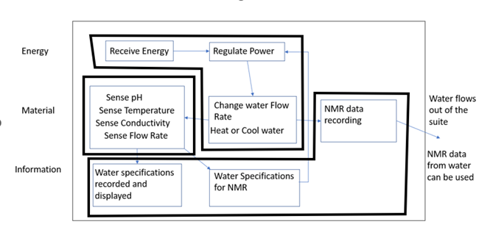

*Figure 9.1: In Situ Water Quality System Function Decomposition*

The functional decomposition diagram serves as the basis for our product layout. Three main sections for the functions, namely Energy, Material, and Information, are presented in Figure 1. Within these sections, the functions, which encompass the data being collected from the water, the suite's power source, and data recording, have been grouped. The sensing function of pH, temperature, conductivity, and flow meter, for instance, has been grouped together as it has all its parts as one single function that aligns well with the other functions. Similarly, the functions of receiving power, regulating power, and changing flow rate, heating, or cooling water, have been grouped together based on their similar purpose of powering and maintaining the system. Finally, the last grouping is focused on data recording and its correlation. Regarding the architecture, integration of most parts is necessary since the sensors, pump, and controller must be attached to the tubing where water comes in. The NMR also requires integration since it is the next stage after the sensors' data collection.

**9.3 Interactions**

The first interaction in our design pertains to the exchange of energy between the power source and the sensors, thereby affecting energy production and expenditure. At present, the power consumption of the sensors is unknown, and it is only after constructing the prototype that a power profile can be established by analyzing their interplay. The pump and sensors are the primary components that are influenced by the input power, and the addition of another pump after prototype development will depend on the power consumption of the existing components.

The computational aspect of our design is derived from the Atlas Scientific hydroponics kit. The sensors transmit data automatically to a server wirelessly via ThingSpeak. In the long-term perspective, the flow rate of the system will be instrumental in determining if the water has been effectively flushed from the NMR system for an accurate reading. Furthermore, the other sensed components will be discernible for comparison with NMR readings using ThingSpeak.

**9.4 Geometric Layout**

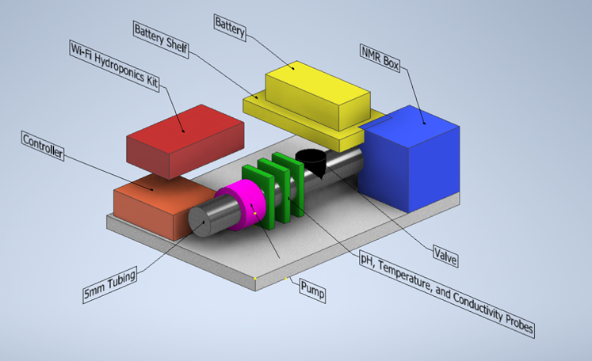

*Figure 9.2: Geometric Layout for In Situ Water Quality System*

The intended purpose of a geometric layout is to depict the integration and placement of various components within a design in a clear and labeled manner. Figure 2 displays the bin as a grey block located at the bottom. The walls of the bin have been removed to illustrate the location of other equipment within. An orange block represents the controller, which ensures continuous sampling of the water. The Wi-Fi Hydronics Kit, which includes three sensors, a temperature probe, a pH probe, and a conductivity probe, is depicted as a red block. The green blocks represent the sensors. The silver tube, approximately 5mm (about 0.2 in) in diameter, will allow water to flow through the bin and into the NMR box. A pump connected to the pipe is represented by the pink cylinder, while the black cylinder at the end of the pipe serves as a valve to regulate water flow. The yellow block displays the battery, which will be placed on a battery shelf. The battery will provide power to the water pump, the hydronics kit with the sensors, the controller, and the NMR box. Finally, the blue cube represents the NMR box.

1. **Engineering Analysis**

The purpose of performing engineering analysis is to serve as a warning of predictable failures or shortcomings in the design. Some potential problems are power supply and regulation, temperature regulation, head loss/pump inefficiency, and water damage to electronics. A failure mode and effects analysis (FMEA) considered the severity of each failure, the probability of occurrence of the failure, and how detectable each failure was, see Table 10.1. Some of the desired values sought after in the analysis were current to the pumps and the flow rate of the pumps while encumbered by the pneumatics of the rest of the design.

*Table 10.1. Failure Mode and Effects Analysis*

|  |  |  |  |  |
| --- | --- | --- | --- | --- |
| **Failure Mode** | **Severity (1-10)** | **Occurrence (1-10)** | **Detection (1-10)** | **Risk Probability Number (1-1000)** |
| Debris in the water blocking the tubing | 5 | 6 | 5 | 150 |
| Head loss causing poor flow velocity | 4 | 4 | 6 | 96 |
| Overheating of the box | 7 | 5 | 7 | 245 |
| Casualty/loss of pressure in PVC or tubing | 4 | 4 | 7 | 112 |
| Power outage | 5 | 4 | 1 | 20 |
| Under or overpowering | 5 | 4 | 5 | 100 |
| Water departure damaging electronics | 6 | 5 | 5 | 150 |
| Sensor failure / poor calibration | 5 | 4 | 8 | 160 |

Power and Circuitry:

The design requires that several components are powered by the same 12V, 5A, 60W power supply. The current required to adequately power the microcontrollers will inevitably take away current passing through the pumps. Using Kirchoff’s Laws and Ohm’s Law, a circuit analysis will provide a basis for future improvement of the design. Table 10.2 outlines the variables in the equations governing this analysis.

Kirchoff Current Law Equation

[1] Iin = Iout

Ohm’s Law | Power Equation

[2] V = I*R | [3] P = I*V

*Table 10.2. Variable Descriptions for Circuit Calculations*

|  |  |  |
| --- | --- | --- |
| **Variable symbol** | **Variable name/description** | **Variable units** |
| Iin | Incoming current | Ampere (A) |
| Iout | Outgoing current | Ampere (A) |
| V | Voltage | Volt (V) |
| I | Electric current | Ampere (A) |
| R | Resistance | Ohm (Ω) |
| P | Electric power | Watt (W) |

*Figure 10.1. Circuit Diagram for Kirchoff’s Current Law*

Calculations:

[4] Node 1:

[5] Node 2:

Arduino draws 0.200A at maximum power, and the Atlas Scientific controller draws 0.310A when operating. See Figure 10.1 for current pathways and the Current Law. Both values were obtained from their specifications on their respective company websites.

[6]

[7]

[8]

[9]

Using Kirchoff’s current rule, the allowable current that runs to the pumps, i5, is 4.490A. This current was to be split between the two pumps, controlled by normally open relay contacts that close when power is supplied by the Arduino (not pictured). Using the theoretical i5 and the circuit diagram with pumps in parallel, the maximum theoretical energy consumption and pump power to use in other calculations.

[10]

[11]

The power drawn from each of these pumps is theoretically 26.94 Watts when running without variable control of the current.

Temperature Regulation

The design is exposed to the elements, in sunlight and overcast conditions. The box containing the electrical components is made of plastic, and an analysis of the temperature over time provided an idea of operating air temperatures within the box. Temperatures from each hour of the day for the past week were averaged together to produce a temperature vs. time graph. The weather conditions for the test were a combination of cold and rainy days in Table 10.3.

*Table 10.3. Calculated weekly average temperature.*

|  |  |  |  |  |  |  |  |  |  |
| --- | --- | --- | --- | --- | --- | --- | --- | --- | --- |
| **Time** | | **Avg. Temperature (Fahrenheit)** | **Mon, Jan 30** | **Tue, Jan 31** | **Wed, Feb 1** | **Thu, Feb 2** | **Fri, Feb 3** | **Sat, Feb 4** | **Sun, Feb 5** |
| 0:00 | 48.71428571 | | 49 | 62 | 62 | 50 | 41 | 37 | 40 |
| 1:00 | | 48 | 50 | 55 | 62 | 49 | 47 | 39 | 34 |
| 2:00 | | 48 | 49 | 56 | 62 | 48 | 47 | 37 | 37 |
| 3:00 | | 47.14285714 | 49 | 56 | 62 | 47 | 47 | 36 | 33 |
| 4:00 | | 47.14285714 | 49 | 56 | 62 | 47 | 47 | 35 | 34 |
| 5:00 | | 47.14285714 | 50 | 56 | 62 | 47 | 48 | 33 | 34 |
| 6:00 | | 46.71428571 | 49 | 56 | 62 | 46 | 48 | 32 | 34 |
| 7:00 | | 46.85714286 | 49 | 55 | 62 | 46 | 48 | 31 | 37 |
| 8:00 | | 46.85714286 | 49 | 55 | 61 | 46 | 48 | 31 | 38 |
| 9:00 | | 47.28571429 | 50 | 55 | 63 | 45 | 46 | 33 | 39 |
| 10:00 | | 49.14285714 | 52 | 56 | 66 | 45 | 47 | 36 | 42 |
| 11:00 | | 51.57142857 | 54 | 61 | 70 | 46 | 49 | 38 | 43 |
| 12:00 | | 54.14285714 | 57 | 61 | 73 | 46 | 52 | 41 | 49 |
| 13:00 | | 55.71428571 | 58 | 62 | 73 | 46 | 54 | 43 | 54 |
| 14:00 | | 57 | 60 | 65 | 72 | 46 | 56 | 44 | 56 |
| 15:00 | | 58 | 61 | 67 | 72 | 46 | 56 | 46 | 58 |
| 16:00 | | 57.57142857 | 61 | 67 | 67 | 46 | 55 | 48 | 59 |
| 17:00 | | 56.57142857 | 61 | 67 | 62 | 47 | 54 | 46 | 59 |
| 18:00 | | 54.14285714 | 59 | 65 | 58 | 47 | 51 | 44 | 55 |
| 19:00 | | 51.71428571 | 54 | 63 | 55 | 47 | 49 | 42 | 52 |
| 20:00 | | 50.85714286 | 56 | 62 | 53 | 47 | 47 | 41 | 50 |
| 21:00 | | 49.28571429 | 55 | 61 | 52 | 47 | 45 | 40 | 45 |
| 22:00 | | 48 | 55 | 61 | 51 | 47 | 43 | 36 | 43 |
| 23:00 | | 47.85714286 | 56 | 62 | 50 | 47 | 42 | 37 | 41 |

*Figure 10.2. Graph of Temperature relative to time.*

The maximum air temperature recorded was 58 degrees Fahrenheit in Figure 10.2. The temperature of the box and its components were expected to be higher than what was recorded, because the analysis was performed neglecting the heat added by the components, as well as the radiation heat transfer from the sun. The overcast conditions in the testing week is also likely to have decreased the average temperature recorded. The conditions were not expected to exceed the microcontroller’s operating temperatures at a much higher 85 degrees Celsius.

*Note: this analysis was performed before the implementation of a voltage regulator, which added a significant amount of local heat to the circuit board in contact with the pump’s microcontroller.

Pressure Calculations

The length of tubing and force of gravity will undoubtedly cause pressure changes on the pumps and within the sensing tube. Theoretically, there will be loss from both the pumps and the altitude gained by the water. Using Bernoulli’s Principle, these losses can be calculated. However, some liberties have to be taken in the analysis, assuming that the water is pure, coming from a reservoir with no flow, and the system is in steady state. The closest our design will get to these theoretical values is after the pumps have been running for a few seconds. See Figure 10.3 and Table 10.4 for reference in the Bernoulli Equation calculations.

*Figure 10.3. Reference Image for Bernoulli Principle*

*Table 10.4. Variable descriptions.*

|  |  |  |
| --- | --- | --- |
| Variable symbol | Variable name/description | Variable units |
| *P* | Pressure | Pa |
| *ρ* | Density of fluid | kg/m^3 |
| *ν* | Fluid velocity | m/s |
| *g* | Acceleration due to gravity | 9.81 m/s^2 |
| *h* | Height | Meters (m) |

Bernoulli’s Equation

Assuming steady state flow, the pressure difference between point one and two is:

[12]

Density of water at 20C is 0.998 kg/m^3, and the pumps produce 500mL/min flow rates. For calculating pressure loss due to height, assume that the velocities are the same at position 1 and two. The ground where the box is placed is elevated about a meter above the water. The outlet of the box is 20cm from the ground. That makes h1 = 0 and h2 = 1.20m.

[13]

11.2 N/m^2

Theoretical pressure drop between the reservoir and the second position is 11.2 Pascals. The head loss from the pumps can be determined in future testing, by gauging flow rate out of the design. For this analysis, frictional losses cannot be calculated with any precision, so they aren’t included. However, it is a theoretical pressure drop and the actual value is likely more based on the turbulence of flow of the water.

Power Restrictions

After the circuit analysis, a better understanding of the power restrictions can be cultivated. Using the current in each of the components from the circuit analysis, Ohm’s Law, and the Power Equation, the energy required to support each component can be derived in Watt Hours (Power*Time). Currently, the power source is plugged into the wall and runs at 60W 12V 5A. This is an important analysis to perform because if one component drastically affects the energy consumption of the prototype, a revision in equipment may improve the design.

Ohm’s Law | Power Equation

[2] V = I*R | [3] P = I*V | [14] E = Power*Time

*Table 10.5. Variable descriptions.*

|  |  |  |
| --- | --- | --- |
| Variable symbol | Variable name/description | Variable units |
| V | Voltage | Volts |
| I | Current | Amperes |
| R | Resistance | Ohms |
| P | Power | Watts |
| E | Energy | Watt Hours |

Calculations:

[14] Pump:

Recall theoretical power of a pump is 26.94W. The pumps will only be running one out of every 6 minutes, 0.1266 hours of time running per hour. The microcontrollers will be running constantly to keep time and transmit data on the fluid below. If the power supply (not a battery) functions well with this design, then a battery with the similar output parameters and a 1260Wh capacity could allow us the following amount of functioning time:

[15]

= 21 hours

The value in finding energy expenditure is that most batteries are rated in W*h. The amount of electricity still in a battery will diminish over time, and given the pumps are the highest power consuming component, the energy expenditure is important to know. The Watt*hours of some commercial car batteries is about 1260.

The calculated time, 21 hours, is the length of time that the design can run with all systems running, including the pumps. The wattage of the design when the pumps aren’t running is:

[16]

60W = 2(26.94W) + P(controllers)

Pcont. = 6.12W

Therefore, the total time that the design runs, assuming no losses, is:

[17]

This gives the design a little more than three days of operational time using a commercial car battery. However, during prototyping, the design will be powered by a conventional power supply, not a battery.

*Note: The final presentation of the design ran on a much smaller wattage and a longer measurement interval, vastly increasing the operational time of the design, because of this analysis.

1. **Manufacturability**

The aspects that regard optimizing production of the product are:

Component selection (Power Supply)

The original power supply was a 60-Watt, but it must be custom made. Instead, a 50-Watt power supply is more abundant. This will change slightly change the design because the 50-W is smaller than the 60-W.

*Table 11.1: Comparison of 50-W and 60-W power supplies*

|  |  |  |
| --- | --- | --- |
|  | 50-W | 60-W |
| Item #: | LRS-50-12 | RS-100-12 |
| Price: | $12.90 | $24.40 |
| Size (LxWxH): | 2.00’’x1.00’’x0.40’’ | 6.26’’x3.80’’x1.5’’ |
| Output Current: | 4.200 Amps | 8.500 Amps |
| Max Power: | 50 Watts | 102 Watts |

By switching from a 60-Watt power supply to a 50-Watt power supply, money is saved. Also, there are more options for the placement of the power supply since it is smaller than the original. The 50-Watt loses some current output compared to the 60-Watt, but there is still enough current for the pumps and hydronics sensors.

Protection (Power Supply)

To protect all electrical components from water damage, a protective cover was designed. The inside would have a raised bottom for the power supply as well as a higher shelf designed for the voltage regulator. Holes would be drilled into a lip to secure to the platform. Other outlets would be made in order to have better wire security.

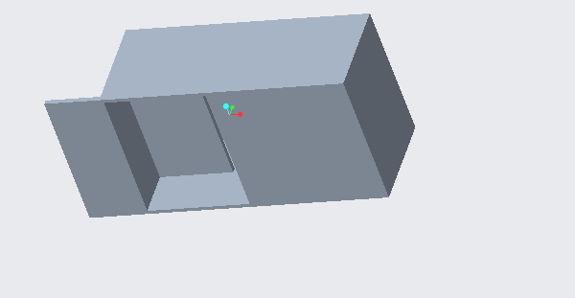

*Figure 11.1: Power Supply Cover*

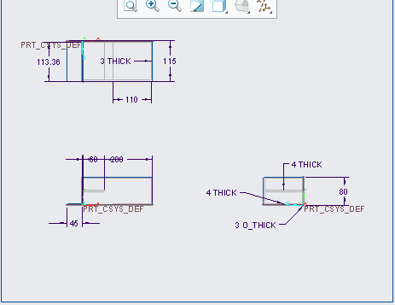

*Figure 11.2: Power Supply Drawing*

Stability (Hydronics Sensors)

The original concept for the sensor's stability was to drill a hole into the PVC waterflow pipe just wide enough for each sensor to fit snug.

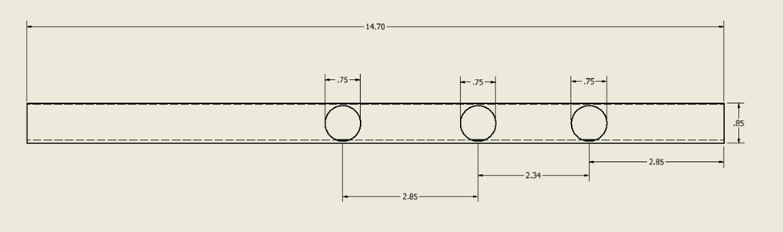

*Figure 11.3: Previous PVC design (Dimensions in inches)*

The new concept will use Cable Glands. The Cable Glands will be able to secure the sensors in place while they are collecting data. The Glands will be attached to a PVC Tee fitting.

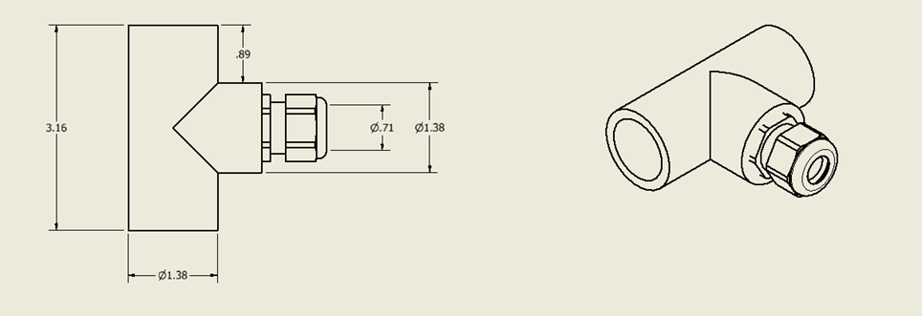

*Figure 11.4: PVC Tee and Cable Gland assembly.*

The result of this change will provide a tight and secure connection for the Hydronics sensors. This will provide a more accurate reading of the data as well as lowering the chances of failure.

Symmetry (PVC)

The previous PVC pipe used for waterflow had three holes, but they were drilled without precision relative to length. PVC Tees will separate the PVC pipe, but symmetry will be taken into effect with the length of each section of pipe. Figure 1 in the section above shows the original design for the PVC pipe.

The new concept will break the PVC pipe into 4 even parts with lengths of 2.63 inches. They will then be attached to three PVC Tees. The top of each Tee will have a Cable Gland screwed on.

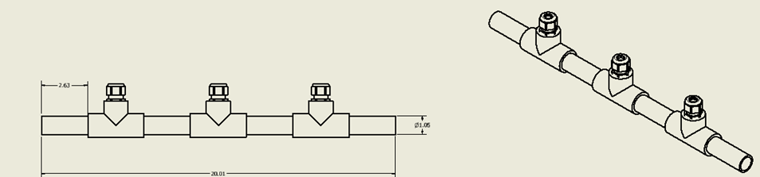

*Figure 11.4: New PVC pipe design*

This new concept has each Tee spaced evenly apart on the PVC pipe. This gives the design a uniform look and affects the sensors by spacing them out more letting them get more accurate readings.

Stability (Hook)

Hooks were designed to go to the end of each side of the platform. These simply designed hooks were created in order to hold the amount of tubing needed for pumping the water. This Would have a cleaner space for working and being able to interact with the actual probes and PVC.

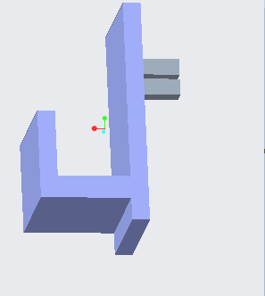

*Figure 11.5: Hook Design*

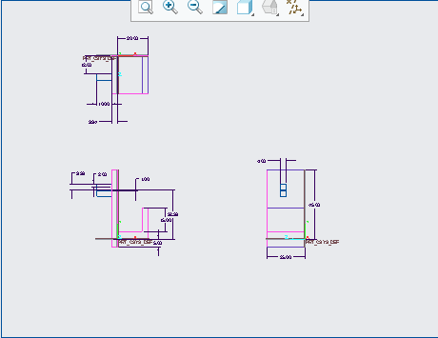

*Figure 11.5: Hook Drawing*

1. **Product Cost/ Economic Analysis**

An economic assessment is important because it can provide a way to predict costs and balance them against alternative courses of action. Money has a time value, is the leading concept in engineering economic analysis. All of the metrics of value that were analyzed are: coat of labor, cost of materials/components, and profitability of the product. A cash flow diagram can be used to deal with financial transactions taking place at various times in the future. A cash flow diagram is used in the report to show the cash inflows (such as sales) and cash outflows (such as capital investment) over an extended period of time. The key outcomes of this report include but are not limited to: Total cost of pneumatics/electronics/hardware for a single unit is $552.91, total cost per unit including labor is $652.91, and selling 3 or 4 units at $750 will recover the investment cost.

The idea of how the product will be used is to have clients use it for data collecting. The goal would be for not only the ARTS-lab, but other labs to be able to use our product to conduct experiments and gain results which we would then create a profit from. We will be assuming for this analysis a lifespan of 2 years, or 24 months (about 2 years). The main upfront cost for this project will come from the materials needed in order to manufacture the product. According to the standard cost per unit table, we have a total of $552.91 for production. This is distributed to Electronics, Pneumatics, and Hardware. The recurring cost includes maintenance, which includes the replacement of any part in the product like the sensors, probes, as well as the pumps and hardware. Taking into account prices for replacement, this can come out to if multiple replacements are needed to a possible $334.31 for the sensors and probes alongside an added number for hardware. This leads to training for future workers at an added $100. This is based on training time and work time in manufacturing the product

**Analysis**

*Table 12.1 – Standard Cost per Unit*

|  |  |
| --- | --- |
| **Electronics** | **Cost per unit $USD** |
| 50W Power Supply | 19.55 |
| (2x) 12V DC Pumps | 73.98 |
| Arduino Microcontroller | 29.95 |
| Atlas Scientific Microcontroller | 379.99 |
| (2x) Relay | 7.39 |
| **Subtotal Electronics** | 510.86 |
| **Pneumatics** | ------------------------------ |
| PVC Base | 1.67 |
| PVC Tees | 2.34 |
| PVC to 5mm adapters | 1.67 |
| PVC Probe Mounts | 10.64 |
| 5ft Silicone Tubing (may vary) | 11.79 |
| PVC Risers | 1.56 |
| **Subtotal Pneumatics** | 29.67 |
| **Hardware** | ------------------------------ |
| General Wiring | 0.31 |
| Breadboard | 1.67 |
| (6x) Nuts | 1.74 |
| (6x) Washer | 3.16 |
| (6x) Bolts | 0.58 |
| Plastic Bin and Cover | 4.92 |
| **Subtotal Hardware** | 12.38 |
| **Total** | **552.91** |

The cost of components of our current prototype is shown in the Cost per Unit above. The total cost per unit omitting labor and incidentals is $552.91. The ARTS Lab prioritizes its purchases through Grangier, an industrial supply company whose website supplied the cost of materials. The only materials that were quoted at different prices were the power supply, Arduino, general wiring and the breadboard. All other pneumatic and industrial components were sourced through Grangier.

In addition to the cost of materials, time to produce and labor cost analyses were performed for the design. Under the assumption that the ARTS Lab covers expenses related to workspace and tool access, it would take an estimated 8 hours of physical work to produce each unit. If we were to hire a worker to perform that task, at $10/hour, with 2 hours of training in calibration and coding, the total cost per unit would be raised to $652.91 per unit.

Recovery of investment could be achieved after the sale of just three or four units at $750. The ARTS Lab already has the tools and facilities required to produce these products, and for us to do the labor ourselves, we would be making about $200 profit per unit sold. That would have us breaking even at about 3 months. For the sake of our theoretical analyses, we assumed that the ARTS lab would allow us to use their facilities for the next 12 months. Then, paying for a new space would affect the cash flow for our product in the next two years.

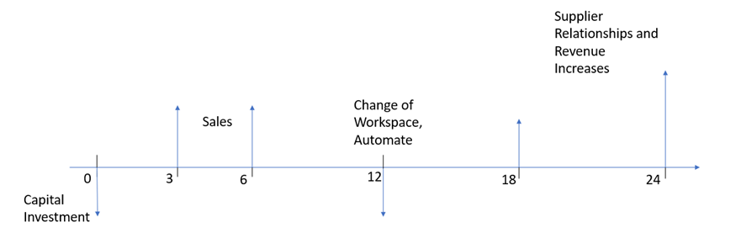

*Figure 12.1- Cash Flow Diagram*

The diagram above shows the cash flow of our product over the course of the next 24 months (about 2 years). It is important to note that these figures are subject to change based on variables that we can’t control, i.e., demand or supply chain problems. The flow is broken into 5 phases that have different costs associated with manufacturing and selling the product.

Phase 1 – 0-3 Months

Initial investment by Professor Downey and the ARTS Lab was the cost of the prototype: $552.91. In the first three months after the final product is created, the target number of sales is 40 units – slightly less than our production capacity to allow for incidental changes in the initial phases of the business. At month 3, if all units are sold, the business will have accumulated about $7,883.60.

Phase 2 – 3-6 Months

Months 3-6 are hopefully months where the cost of materials can be decreased via a relationship with vendors at Grangier or Atlas Scientific, or by buying more materials in bulk. Buying in bulk poses a problem with storage space in the lab, so that problem should be attacked soon. However, the product would continue to make gains without discounts.

Total at 6mo =~ $7,800 + (12 weeks) * ($197.09/unit) * (4units/week) =~ $17,260

Phase 3 – 6-12 Months

A decent profit has been achieved at this point and we would begin to look for space separate from the ARTS Lab so that they can continue with their work without manufacturing operations taking place. A reinvestment in the product and business would make the business more sustainable. To rent an 800 square foot office space in Columbia, we found that the cheapest option amounts to about $750/month. We assume that moving operations in this phase will cut down production and we will lose some money buying the tools and equipment to manufacture in this space. We estimated that a soldering iron, tables, drills and tools would cost about 200$. If we made the move at 12 months, the following calculations could be applied.

Total at 12 months = ~$17,260 + $18,920 (6-12 profits) – $750*12months (rent) – $250 (tools)

= ~$26,930 remaining after moving, paying a year lease, and buying equipment.

Phase 4 and 5 – Beyond

As the business grows, we have the funds to improve the design and could potentially upcharge the product as well as hire workers to produce it. We would pay laborers $10/hour and would attempt to improve profit per unit to roughly $225/unit via business relationships with suppliers or by improving the design to optimize for cost.

After 2 Years Total: ~$26,930 + (12 months operation) (16 units/month) ($225 profit/unit)

= ~$43,200

The net present worth of the business (if we were to sell this commercially) is represented by the net inflow subtracted by net outflow. The current amount spent on this product is the cost of materials: $552.91. After refinement of the prototype, this cost is subject to change, but we would start the price for our product at $750 per unit. Charging sales tax to the customer, our profit would be $197.09 per unit. If we could produce 4 of these per week, $3153.44 is the profit after a month of selling if demand meets supply.

**Conclusions/Recommendations**

An economic analysis is crucial because it may help forecast expenses and weigh them against potential alternatives to a course of action. The suggested fixture, in sum, is a useful addition to the ARTS Lab. Not only is it anticipated to boost annual profits, but it also lowers risk, both indicate profitability in this project. The internal rate of return and net present value for this project were calculated using criteria such as price per unit, upfront costs, and time to break even. The investment might be recovered once just three or four units at $750 are sold. The ARTS Lab already has the equipment and resources needed to create these products. A final suggestion would be that while we have to idea to move to an office space to help in manufacturing, considering the cost of moving any equipment from the lab would probably be needed.

**Appendix/References**

[1] Office Space Rental Reference - <https://www.loopnet.com/Listing/2754-2772-Rosewood-Dr-Columbia-SC/22382902/>

[2] Probe and Sensor References - <https://atlas-scientific.com/ph/>

- <https://atlas-scientific.com/temperature/>

- <https://atlas-scientific.com/kits/conductivity-k-1-0-kit/>

1. **Testing**

To engineer and quantitatively define the shortcomings of the design, different methods of testing were done. Testing parameters were chosen based on criticality to design function. The volumetric flow rate, average power consumption, water leakage, and running time without maintenance were tested rigorously. The parameters mentioned are a part of the target specifications in Table 13.1

*Table 13.1. Table of target and fallback specifications.*

|  |  |  |  |
| --- | --- | --- | --- |
| **Metrics** | **Units** | **Target Specification** | **Fallback** |
| Measures conductivity | micro Siemens/cm | 15 | 5-60 |
| Measures pH | none | 7 | 6.5-7.5 |
| Measures temperature | [C] | 22 | 19-25 |
| Measures flow rate | [lpm] | 0.57 | 0.50-0.64 |
| Electrical components must stay dry | [Boolean] | True Positive | TP - TN |
| Temperature regulation near operating temperature of electrical components | [C] | 23 | 40 - 60 |
|  |  |  |  |
| Fluid temperature change over time | [C/min] | 5 | 20 |
| Data sets per unit time | [data sets/min] | 0.2 | 0.1 |
| Time without maintenance | [days] | 10 | 2 - 6 |
| Portability | [lb.] | 40 | 25 - 55 |
| Average Power consumption | Watts | 6.5 | 5.0 - 8.0 |

Volumetric flow average

The target value is 0.57 L/min while the fallback value ranges from 0.50-0.64 L/min.

Equipment: Pumps, Metered Beaker, Bucket of Water

Procedure: Set the microcontroller to run the pumps in 10 second intervals. Put the inlet tubing into the water bucket. Completely purge the system of any air before taking readings. To take a reading, insert the outlet tubing into the empty metered beaker. Allow the pump to run for its allotted cycle time and record the volume of water in the graduated cylinder.

*Table 13.2: Volumetric Flow Rates*

|  |  |  |
| --- | --- | --- |
| Time (min) | Volume (mL) | Flow Rate (L/min) |
| 0.17 | 85 | 0.51 |
| 0.17 | 92 | 0.552 |
| 0.17 | 90 | 0.54 |
| 0.17 | 91 | 0.546 |
| 0.17 | 94 | 0.564 |
| 0.17 | 95 | 0.57 |
| 0.17 | 96 | 0.576 |
| 0.17 | 96 | 0.576 |
| 0.17 | 97 | 0.582 |
| 0.17 | 96 | 0.576 |
| 0.17 | 95 | 0.57 |
|  | AVG (L/min) | 0.560 |

Equations Used: Flow Rate Q=Volume/time

Average power consumption

The target value is 6.5 Watts while the fallback value ranges from 5.0-8.0 Watts.

Equipment: Variable Power Supply

Procedure: Attach the 12V DC leads from the voltage regulator to the power supply [out]. Adjust the variable power supply to a 12V 60W signal and turn on the output. While the prototype runs, take intermittent values of output wattage from the power supply screen. Take note whether the pumps are running or not for each power reading.

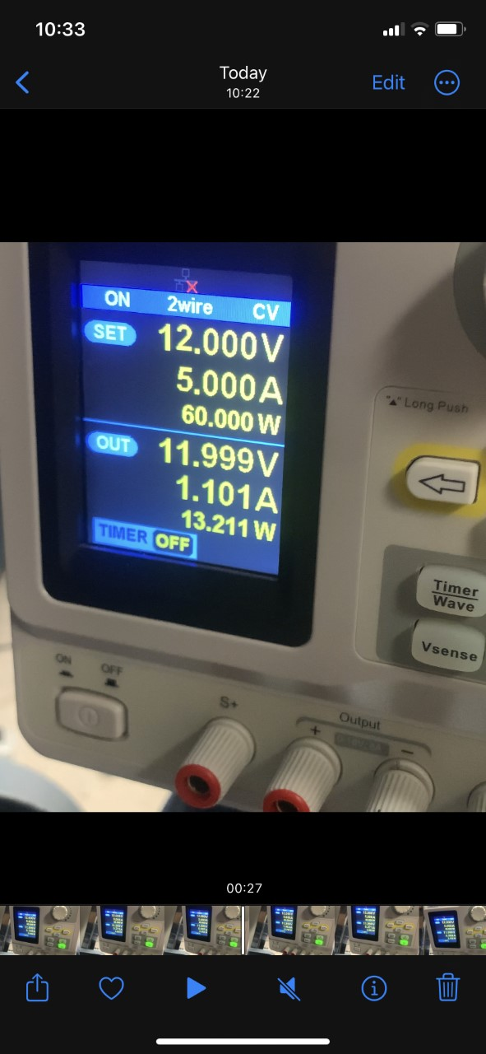

*Figure 13.1. Variable Power Supply*

The wattage of the prototype was vastly lower than the initial ceiling of 50W provided by Professor Downey. In Figure 13.1 the output wattage was 13.211W, the maximum wattage obtained while the pumps were running.

Water leakage

The target value is True positive while the fallback value is true positive-true negative.

Equipment: Paper Towel, Metered Beaker

During the first testing attempts, the sources of water leakage were identified and fixed. The barbs connecting the tube to PVC were exchanged with cable glands to prevent a casualty. Once the initial flooding was fixed, the area around the sensing components was dried to ensure that there were no other leaks in the system.

In the later, outdoor endurance testing, the design was exposed to proper operating temperatures and pulled samples from a canal. At the maximum temperatures of the day, the design displayed absolutely no leaking. If a leak had been detected, the water in the box is to be poured into the metered beaker. That volume divided by the time the prototype operates is the specification value for water leakage. For the outdoor endurance test, that was 0 L/min.

Running time without maintenance

The target value is 10 days (about 1 and a half weeks) while the fallback value ranges from 2- 6 days. The system is developed and designed to work without maintenance for a period of 10 days. Unfortunately, due to security concerns and operator time constraints, it was only tested for 4 hours, and not for a full 10-day duration. During the testing period, the system performed decently within reason for the time it ran.

Although it was not a previously targeted specification for testing, more conclusions were made based on sampling data during the endurance testing. See Figure 13.2 for the conductivity data. The first noticeable issue was the variance in the conductivity probe’s sensing. There is a problem with the orientation of the probe that produces an air bubble in the sensing component. This is a foreseeable issue in the Atlas Scientific datasheet, Appendix A. The stabilization of the conductivity readings is not a result of the sample, but the air bubble produced by the pumping of water into the PVC pipe.

*Figure 13.2: Graph of Conductivity*

Furthermore, the conductivity probe did not have ample time to stabilize readings between sampling intervals – the amount of time for sensing before a new sample is pumped into the PVC pipe. **The temperature at peak hours of the day is speculated to have disabled the Arduino from controlling the pumps when left idling for more than 3 minutes.**

The data from the pH and temperature sensors are also clearly affected by the limited sampling time and high temperatures of midday, as show in Figures 13.3 and 13.4. The temperature readings appear to increase within the sampling time, indicating poor insulation in the sensing tube. A close look at the pH readings shows that stabilization occurs just before the next sampling cycle.

*Figure 13.3. Temperature Readings*

*Figure 13.4. pH Readings*

1. **Final Design**

*Figure 14.1. Design Photo*

In Figure 14.1, a photo of the final design sampling water is provided. The design features a 12V power supply capable of supporting 60W, which powers two microcontrollers that control the pump running intervals, data collection, and transmission. Figure 14.3 is a diagram for the PERF board and voltage regulator that allows the microcontrollers to function on the same power supply as the 12V peristaltic pumps. An Arduino Nano is responsible for controlling the pumps and keeping time for sampling intervals. The Atlas Scientific Hydroponics Kit in Figure 14.2 is responsible for the sampling, calibration, and transmission of data to a server via ThingSpeak, a data aggregation software through MathWorks.

*Figure 14.2. Atlas Scientific Hydroponics Kit (See Appendix A)*

*Figure 14.3. Circuit Diagram*

*Figure 14.4. PVC Tees with Cable Glands for probes*

The probes that collect data on the water samples are mounted on a PVC assembly (Figure 14.4) secured to an aluminum frame. The cable glands are screwed tightly to prevent leaks and ensure the probe is completely wetted. This design makes calibration of the probes simple, and each of the probes easily replaceable. The components for the sensing pipe and the rest of the prototype are in Figure 14.1

*Table 14.1. Bill of Materials*

|  |  |  |
| --- | --- | --- |
| **Electronics** | **Pneumatics** | **Hardware/Tools** |
| 60W Power Supply | PVC Base ½ in | Gauge 20 Wiring |
| (2x) 12V DC Pumps | PVC Tee x3 | Soldering Iron |
| Arduino Microcontroller | PVC Cable Glands x5 | Nuts x12 |
| Atlas Scientific Microcontroller | PVC Primer and Glue | Washer x12 |
| Temperature Probe | 5mm Tubing (as needed) | Bolts x12 |
| Conductivity Probe |  | Plastic Bin and Cover |
| pH Probe |  | Extruded Aluminum |
| PERF Board |  |  |
| 12V-5V Voltage Regulator |  |  |

1. **Conclusions on Designed Products**

This design is excellent at providing fresh samples, without leaks, and within given power requirements. Although it does those things well, there are pitfalls in the design that prevent the appropriate sampling procedures from taking place. For example, temperature in the box when exposed to sunlight at the top of the day prohibits the design from pumping fresh samples after idling for more than three minutes. The three minute pause is just barely substantial for getting stabilized measurements from the Atlas Scientific probes.

Another casualty of the heat is the temperature of the water being sampled. Water in the silicone tube as well as within the PVC pipe in idle will retain heat. There is very little insulation where the measurements are taking place, so an increase in the temperature is apparent from the sensor’s data in the testing chapter (Ch.10).

In future iterations of the design, two main problems must be addressed. The first is the inability of the pumps to run if left to rest in a charged state for longer than 3 minutes. The pumps must keep water static in the assembly long enough to generate a stable reading. To troubleshoot the pneumatic problem, it is recommended to test the design by changing the height at which sample water exits the box. Also, test for current supply when the voltage regulator is operating at high air and local temperature.​

    The second issue to address is the air pocket that essentially disables the conductivity probe. There could be a simple solution as easy as reorienting the PVC or probes to get a better reading. The other solution would be to change the design entirely to an internal reservoir concept referenced in concept selection matrix, where probes would take readings from a static reservoir that drains after sufficient sampling has taken place​.

*Table 15.1. Satisfactory Needs*



The specifications that we retained from the sponsor are listed in Table 15.1. In the future of this project, more metrics are going to be required to have a successful product. To find and retain accurate specifications and fallback values, a control must be used, particularly with the sensors for pH and conductivity. For example, there was no way to confirm the actual pH, conductivity, or temperature of the water being sensed. More rigorous testing of the probes, in different arrangements, will likely result in a more effective design. To do this, it is recommended a control sensor suite is used.

The primary lesson this team learned is that free networking is the key to rapid progress in design. Putting as many eyes as possible on a concept is an excellent way to gain new perspective. It was also discovered that changes in a design can be rapid and drastic, but it will influence quantitative analysis if the changes aren’t documented properly. In the future, proper documentation practices in coordination with good teamwork will be the key to our success.

1. **Acknowledgments**

We would like to thank Professor Downey and Professor Sabalowsky for their guidance on this Senior Design project. We would also like to profusely thank the ARTS Lab for their hospitality in their space. Particularly we would like to thank Ryan, Mohammed, and Joe from the lab for their help in obtaining tools and materials to fabricate the design.

1. **Appendix**

**[A]** Atlas Scientific Hydroponics Kit Datasheet – [**https://files.atlas-scientific.com/Wi-Fi-Hydroponics-kit-setup-guide.pdf**](https://files.atlas-scientific.com/Wi-Fi-Hydroponics-kit-setup-guide.pdf)

**[B]** *The Complete Phase Diagram of Monolayers of Enantiomeric N-Stearoyl ...* <https://pubs.acs.org/doi/10.1021/acs.langmuir.2c01936>.

**[C]** “Conductivity Measurement & Testing: Thermo Fisher Scientific - US.” *Conductivity Measurement & Testing | Thermo Fisher Scientific - US*, <https://www.thermofisher.com/us/en/home/life-science/lab-equipment/ph-electrochemistry/conductivity-measurement-testing.html>.

**[D]** Dabadi), Sadrish. “Ph Values of Water with Ph Level Chart.” *Earth and Human*, 11 June 2022, <https://earthandhuman.org/ph-values-of-water/#:~:text=Different%20pH%20Levels%20of%20Typical%20Materials%20%20,%20Approx.%207.5%20%203%20more%20rows%20>.

**[E]** Friedman, Daniel J. “Building Water Flow Rate Calculation & Measurement Procedures Thanks to Shelly Weinberg.” *Water Flow Rate Calculation & Measurement Procedures Shelly Weinberg and Daniel Friedman*, Daniel J. Friedman at InspectApedia.com, <https://inspectapedia.com/water/Water_Flow_Rate_Measurement.php#:~:text=Nominal%20%26%20Peak%20Water%20Pipe%20Flow%20Rates%20,%20%203000%20%209%20more%20rows%20>.

**[F]** Klements, Michael. “How Long Can an Arduino Run on Batteries? I Tested 6 of the Most Common Boards.” *The DIY Life*, 17 Aug. 2020, <https://www.the-diy-life.com/how-long-can-an-arduino-run-on-batteries-i-tested-6-of-the-most-common-boards/#:~:text=As%20expected%2C%20this%20board%20draws,Next%20we%20have%20a%20Nano>.

**[G]** Mlblevins. “Density of Water at Room Temperature.” *Science Struck*, 20 Dec. 2010, <https://sciencestruck.com/density-of-water-at-room-temperature>.

**[H]** “Referencing of the Chemical Shift Scale in the NMR Data.” *NMR Wiki RSS*, <http://nmrwiki.org/wiki/index.php?title=Chemical_shift_referencing>.

**[I]** “What Is the Right Temperature Set Point for an Electrical Enclosure?” *ACHR News RSS*, ACHR News, 21 June 2019, <https://www.achrnews.com/articles/141465-what-is-the-right-temperature-set-point-for-an-electrical-enclosure#:~:text=The%20acceptable%20operating%20temperature%20for%20most%20electrical%20devices,maintenance%20burden%2C%20and%20can%20actually%20pose%20operational%20threats>.

**[J]** “Wi-Fi Hydroponics Kit.” *Atlas Scientific*, <https://atlas-scientific.com/kits/wi-fi-hydroponics-kit/>.

# **[K] CA2968582C -** Nuclear magnetic resonance apparatus, systems and methods

[https://patents.google.com/patent/CA2968582C/enq=nuclear+magnetic+resonance&oq=nu](https://patents.google.com/patent/CA2968582C/en?q=nuclear+magnetic+resonance&oq=nuclear+magnetic+resonance) clear+magnetic+resonance

**[L] US9005416B2** – pH sensor

[US9005416B2 - pH sensor - Google Patents](https://patents.google.com/patent/US9005416B2/en?q=ph+sensors&oq=ph+sensors)

**[M] US8136414B2** – Flow metering

[US8136414B2 - Flow metering - Google Patents](https://patents.google.com/patent/US8136414B2/en?q=dp+meter&oq=dp+meter)